# PE-8 – More About Variables

1. Which of the following conversions can't be performed implicitly:
2. int to short
3. short to int
4. bool to string
5. byte to float

a, c

1. Give the code for a color enumeration based on the short type containing the colors of the rainbow plus black and white. Can this enumeration be based on the byte type?

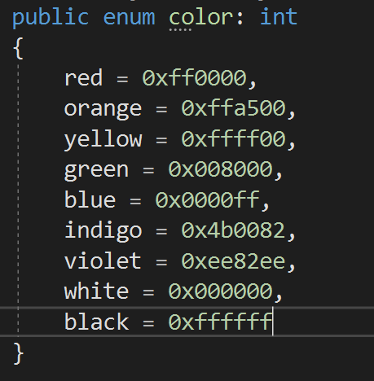Usually, color is represented in hex code or RGB. I think neither of them needs short type to create an enumeration. For hex code, it needs 24-bit to represent a color, but short is only 16-bit. For RGB, each of them need 8-bit, so byte is enough. We can use R&G&B in enum to represent a specific color.

1. Write the C# code that creates an array of doubles with a size of 4 and assigns values to the array. The identifier should be *precipitation* and the values are 0.45, 2.78, 0.04 and 1.22.



1. Complete the *for* loop to assign values into the array. When the loop is finished running, the array should hold the values 1, 2, 3, 4, 5.

int[] ascendingNumbers = new int[5];

for( int i = 0; i < ascendingNumbers.Length; i++ )

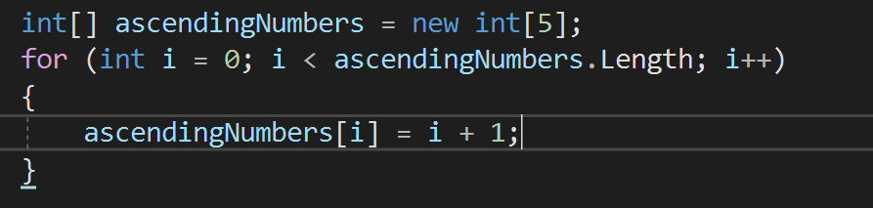

1. Given the formula z = 3y2 + 2x - 1 write a console application to calculate z for the following ranges of x and y:
   * -1 <= x <= 1 in 0.1 increments
   * 1 <= y <= 4 in 0.1 increments

Use a 3-dimensional array double[,,] to store the values of x, y and z for each computation.

GitHub project URL:

1. Will the following code compile? If not, why not? Hint: there are 3 errors.

string[] blab = new string[5];

string[5] = 5th string;

string[] blab = new string[5];

blab[4] = "5th string";

1. Write a console application that accepts a string from the user and outputs a string with the characters in reverse order.

GitHub Project URL:

1. Write a console application that accepts a string and does a case-insensitive replacement of all occurrences of the **word** "no" with "yes".

For example, the string:

She said, "No, I have nothing in my purse!"

Should be converted to:

She said, "Yes, I have nothing in my purse!"

GitHub Project URL:

1. Write a console application that places double quotes around each word in a string.

GitHub Project URL:

## Submission

Upload this completed document to the corresponding MyCourses dropbox.

Add, Commit and Push the 4 projects for #5, 7, 8, and 9

**All codes are in https://github.com/whisperers26/IGME206---Homework.git**